SDEM® 2.0 Getting Started Guide
This training course is intended for those who selected "SDEM 2.0 Getting Started Guide," for those not
familiar with SDEM including the old SDEM, in the SDEM 2.0 Introductory Training.

1. What is SDEM?
What you will understand by the end of this chapter
- Why standardization is required in system development
- What is SDEM, Fujitsu's standard process structure

Chapter 1 explains what SDEM is.
By the end of this chapter, you will understand why standardization is required in system development and
what is SDEM, Fujitsu's standard processes.

1.1 Need for Standardization - Why Standardization is Required -
To build quality, the processes for planning, design, implementation,
and testing must be done in the correct order.

To provide customers with systems they can use with peace of mind,
an architecture for work at the same quality by many parties is required.

Standardization

First is an explanation of why standardization is required in system development, operation, and
maintenance.
To create high quality in systems, the processes for planning, design, implementation, and testing must be
done in the correct order.
In addition, to provide customers with systems they can use with peace of mind, an architecture for work at
the same quality by many parties is required.
The standardization of processes and the development architecture allows many parties to work at the same
quality in the correct order.
Examples of standardization are:
- "standard processes" that define work contents and procedures, and
- "standard documents" that define the formats and rules of design, management, and other documents.

1.1 Need for Standardization - Non-Standardized State -
Quality varies depending on the person
Work that should be done and descriptions in documents are omitted
Interfaces are incoherent and do not work well together
Maintainability is not good at the time of design change or repair after operation

So what kind of problems occur when processes and documents are not standardized?
For example, the following problems occur:
- Quality varies depending on the person
- Work that should be done is omitted
- Interfaces are incoherent and do not work well together

To prevent such problems, the required work and deliverables must be clarified. Standardization, that is, the
processes and architecture in place, is important to ensure that the required work is carried out properly,
even by those without experience.

1.1 Need for Standardization - Effects of Standardization -
Effect 1 - Work and quality are independent of people.
Effect 2 - Even inexperienced members understand the correct procedures for manufacturing with good quality.
Effect 3 - Information can be accurately transmitted without omission to the people in each role.
Effect 4 - Maintainability during operation and maintenance is improved by the handover of documents that comply with development standards.

Various effects can be expected from standardization.

Firstly, when the documents created with the standard documents, the items written in them, and the
required work are defined, you can prevent a dependence on the individual in work and quality.

Secondly, when the required work and its procedures are shown as standard processes, even
inexperienced members can carry out manufacturing in the correct order.

Thirdly, when the role division and required work in standard processes are clarified, you can convey
information accurately and without omission and unify how it is understood by the parties concerned.

Fourthly, after documents created using standard documents are handed over for operation and
maintenance, everyone understands what is written and where it is, which improves maintainability.

The next page explains what kind of standardization is underway at Fujitsu.

1.2 Fujitsu Standardization = Standard Process Structure "SDEM"
Fujitsu's standard process structure "SDEM"
- Systematizes the basic concepts and elements of planning, development, operation and maintenance, and quality assurance activities in Fujitsu's system development as standard processes
- Comprehensively systematizes the who, what, when, and what order of work to prevent omissions and ensure quality
- Gives a bird's-eye view of the whole like a map so that users understand their positions in it and communicate in a common language with the parties concerned

Fujitsu's standard process structure is called "SDEM."

It shows the basic concepts of planning, development, operation and maintenance, and quality assurance activities for systems handled by Fujitsu.

It is a bible for comprehensively systematizing the who, what, when, and what order of work to prevent omissions and ensure quality.

By using SDEM, you can get a bird's-eye view of the whole like a map and understand your position in it. So you will be able to communicate in a common language with the parties concerned.

1.3 Support for Global/De Facto Standards
Systematization based on global/de facto standards such as ISO/IEC/JIS, Common Frame, PMBOK, and ITIL, and Fujitsu's practical know-how

SDEM has been systematized by incorporating various domestic and global standards, such as Common
Frame and ITIL, in addition to Fujitsu's conventional practical know-how.
As a result, it can be used for projects that require compliance with global standards.

1.4 History of Standardization at Fujitsu
Created in 1976, SDEM has more than 40 years of accumulated knowledge,
a compilation of Fujitsu's know-how, and is still evolving along with global trends.

1980
Software Development standards SDEM
SP to ME

1990
System development Standards SDEM ® 90
SP, SA to OT, ME

1995
System development standards SDEM ® 90 [Common Frame supported]
Contract work
System development work
SP, SA to OT, ME
Quality assurance work
Organizational improvement work
System audit work

1999
Standard process structure for solution oriented planning, development, operation, and maintenance SDEM ® 21
Contract process
Planning process  VP, SP | Development process  SA to OT | Operation & maintenance process  OM
Organizational management process
System audit process

2000

Standard process structure for planning, development, operation, and maintenance SDEM®
Planning process  VP, SP | Requirement definition process  RD | Development process  UI to ST | Operational test & transition process  OT | Operation & Maintenance process  OM
Organizational management process
System audit process

2007

2021

Since ‘18 - IPA
SEC BOOKS: User's Guide for Successful System Reconstruction
Points for Success in System Reconstruction

Updated on premise that "it is natural for existing systems to exist"
- Tacit knowledge from those experienced in reconstruction, turned into explicit knowledge, reconstruction work process expanded and systematized
- WBS refined to match actual situations of projects so that standards are more practical

Fujitsu's SDEM has more than 40 years of accumulated knowledge, which continues to be used in the field as a compilation of Fujitsu's know-how.

Here is a brief explanation about its history.

SDEM was born in 1976.
The purposes were to break away from development practices that depend on individual skills, and to curb the ever-increasing development costs.
In 1995, SDEM supported the common framework established as an industry standard in Japan. At the time, not only system development but also contract and organizational work was added, creating a prototype for
the current SDEM processes.
Since then, SDEM has continued to incorporate elements of international and de facto standards, responding to changes in the environment surrounding system construction.

In 2021, it was reformed into SDEM 2.0.
The main theme of SDEM up to then was "creating a new system."
However, it is now commonplace to have an existing system.
Therefore, SDEM was updated on the premise that "it is natural for existing system to exist."

SDEM will continue to evolve in the future.

2. SDEM Structure
What you will understand by the end of this chapter
- What are SDEM categories, phases, and WBS

Chapter 2 explains the SDEM structure.
By the end of this chapter, you will understand the SDEM categories, phases, and WBS.

2.1 SDEM Processes
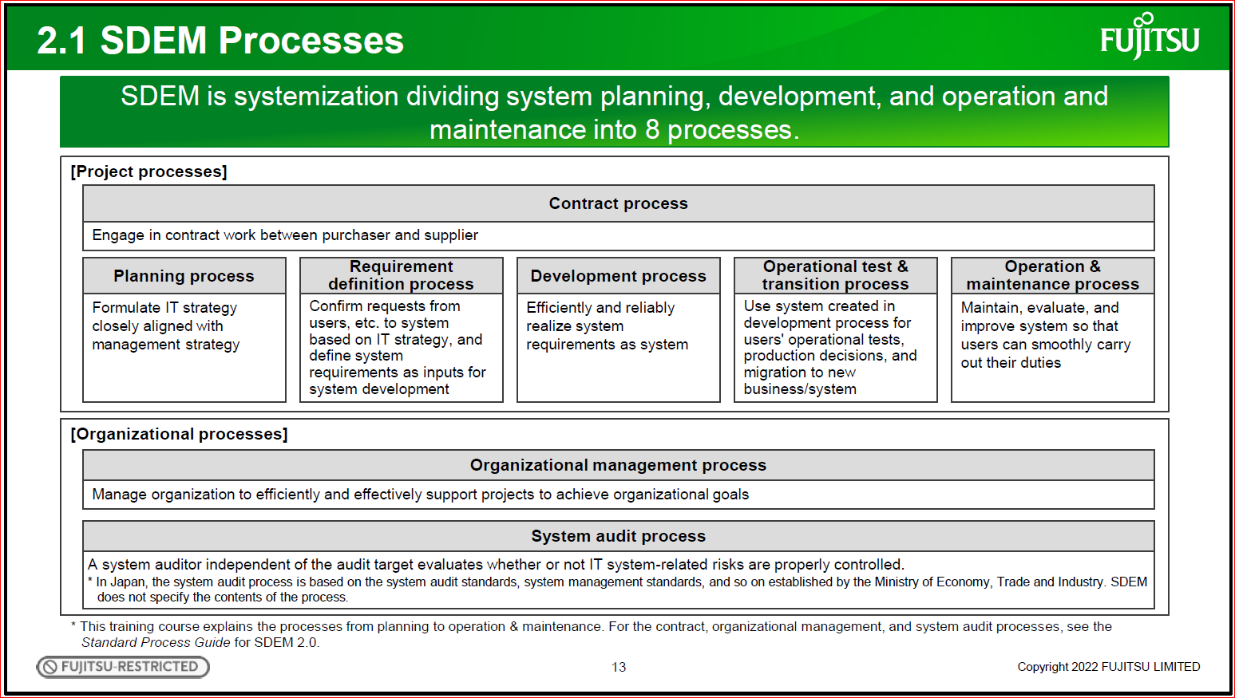
[Project processes]
SDEM is systemization dividing system planning, development, and operation and
maintenance into 8 processes.
Contract process
Engage in contract work between purchaser and supplier
Requirement
definition process
Confirm requests from
users, etc. to system
based on IT strategy, and
define system
requirements as inputs for
system development
Planning process
Formulate IT strategy
closely aligned with
management strategy
Development process Operational test &
transition process
Operation &
maintenance process
Efficiently and reliably
realize system
requirements as system
Use system created in
development process for
users' operational tests,
production decisions, and
migration to new
business/system
Maintain, evaluate, and
improve system so that
users can smoothly carry
out their duties
[Organizational processes]
Organizational management process
Manage organization to efficiently and effectively support projects to achieve organizational goals
System audit process
A system auditor independent of the audit target evaluates whether or not IT system-related risks are properly controlled.
* In Japan, the system audit process is based on the system audit standards, system management standards, and so on established by the Ministry of Economy, Trade and Industry. SDEM
does not specify the contents of the process.
* This training course explains the processes from planning to operation & maintenance. For the contract, organizational management, and system audit processes, see the
Standard Process Guide for SDEM 2.0.

First is an explanation of the SDEM process structure.
The SDEM processes are broadly divided into project processes and organizational processes.
The project processes consist of processes for the system life cycle and the contract process. The
processes for the system life cycle consist of five processes: planning, requirement definition, development,
operational test & transition, and operation & maintenance.
The organizational processes are processes handled by the organization to support a project, and they
consist of the organizational management process and system audit process.
This training course explains the processes from planning to operation & maintenance, which are related to
the system life cycle.
For the contract, organizational management, and system audit processes, see the Standard Process Guide
for SDEM 2.0.
Chapter 4 introduces the Standard Process Guide.

13

2.2 Process Structure
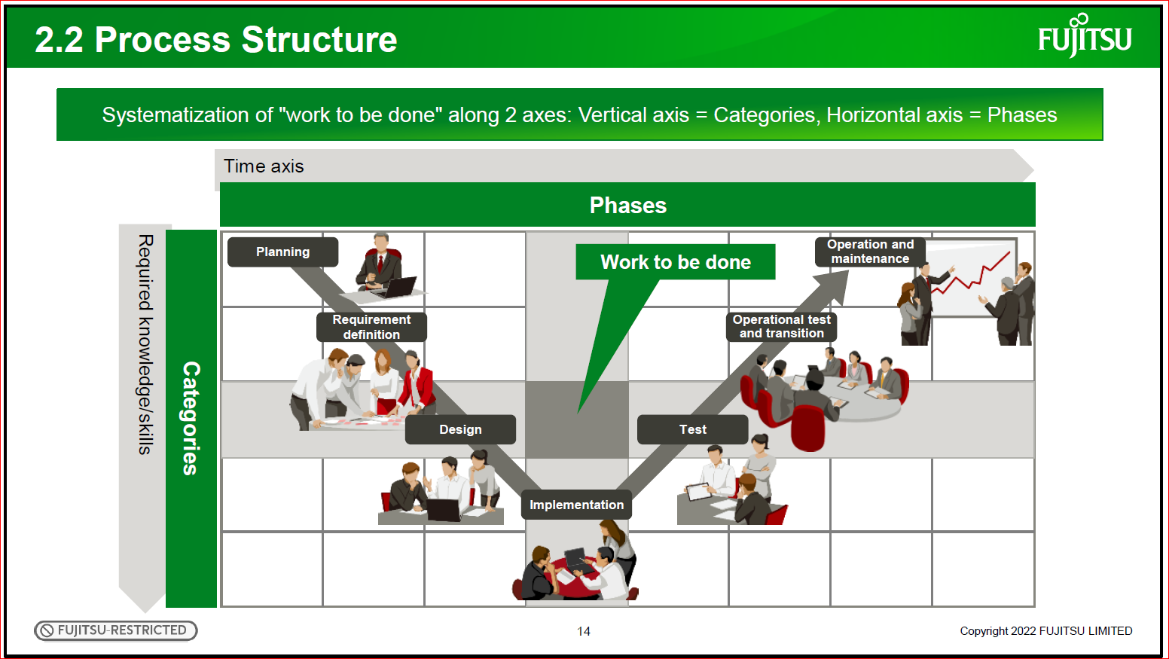

Here is an explanation of the structure of the SDEM processes.
The SDEM structure is a matrix with two axes: categories on the vertical axis, and phases on the horizontal
axis.
The vertical axis shows the "required knowledge/skills" categories, and the horizontal axis shows the
phases, which are the time axis.
"Work to be done" is defined at the intersection.
The vertical axis clarifies "who," the horizontal axis clarifies "when," and the intersection clarifies "what."
The subsequent pages explain the vertical axis "Categories" first, the horizontal axis "Phases" next, and
"work to be done" finally.

14

2.3 Categories - Categories in Each Process –
Categories defined for each process
● Main categories of the work required to carry out each process
● Categories based on work relevance and the relevance of knowledge/skills required for work
Planning process | Requirement definition process Development process Operational test & transition process | Operation & maintenance process
A: Business management  B: Business  C: System usage  D: System  E: Project management | A: Business management  T: Quality assurance (Overall test)  B: Business  C: System requirements  D: Application  E: Application infrastructure  F: System infrastructure  G: Operation and maintenance  H: Transition & deployment  I: Development support  J: Project management | A: Business management  B: Business  C: IT service management  D: System operation and maintenance  E: Infrastructure provision  G: Project management

First is an explanation of the Categories vertical axis.
There are the main categories of work required to carry out each process. The categories are based on work
relevance and the relevance of knowledge/skills required for work.
Therefore, they can be useful for teaming in a project, as an example.
The categories have been appropriately defined based on the characteristics of the planning process, the
requirement definition, development, operational test & transition processes, and the operation &
maintenance process.
15

2.3 Categories - System as Combination of Many Technologies -
A system is a combination of many technologies.
A system is a "castle" made up of many technologies in a stack.
Architecture for connecting and moving everything
Important! System does not work until it is all put together

Starting with this page, here is a further explanation of the categories in the requirement definition, development, operational test & transition processes, which are the processes of system construction.
First of all, as a premise, a system is made up like this castle with many technologies in a stack. Be aware that an architecture for connecting and moving everything is important, and that the system does not work
until it is all put together.

16

2.3 Categories - Correspondence Between System and Categories –
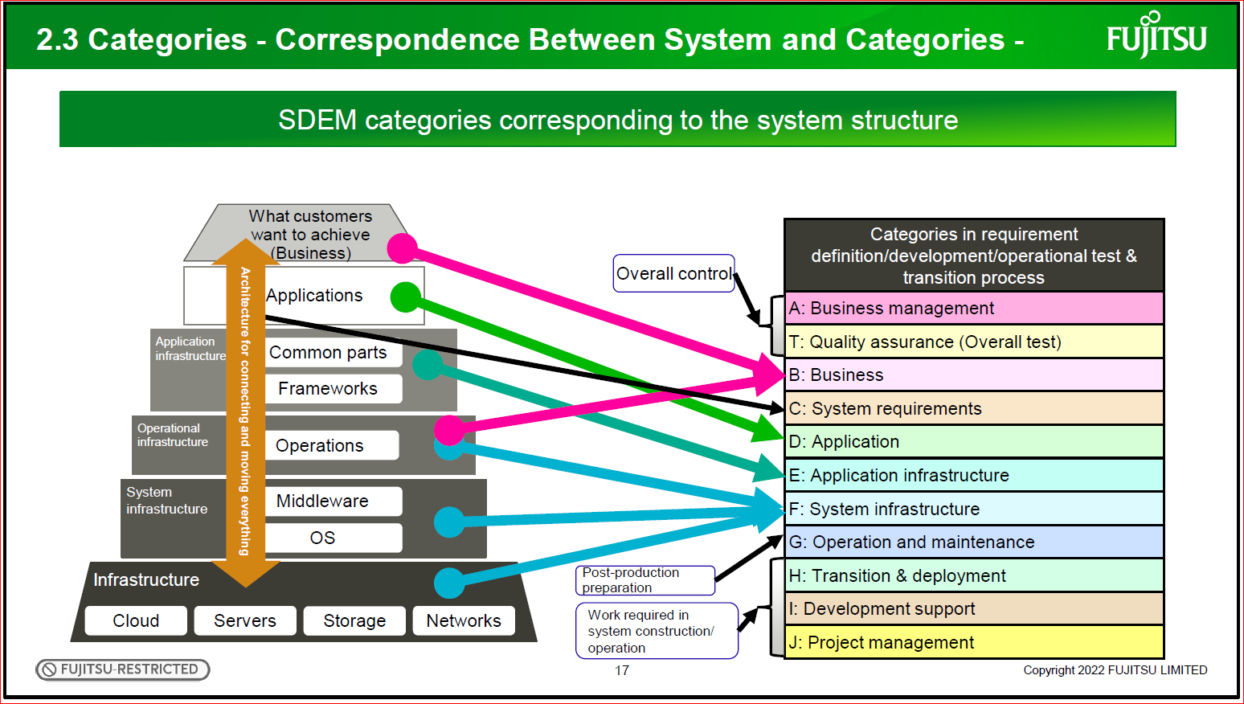
Categories in requirement definition/development/operational test & transition process
A: Business management
T: Quality assurance (Overall test)
B: Business
C: System requirements
D: Application
E: Application infrastructure
F: System infrastructure
G: Operation and maintenance
H: Transition & deployment
I: Development support
J: Project management

The system structure corresponds to the categories in the requirement definition, development, and
operational test & transition processes.
One category corresponds to "what customers want to achieve" and others correspond to "work required in
system construction/operation" as roles required for system construction. There are other categories as well
corresponding to parts of the system structure.
Each category is classified by adding an alphabet letter; for example, "A: Business management" and "B:
Business."
Chapter 3 explains the contents of each category.

17

2.4 Phases - Time Divisions in System Life Cycle –
"Work to be done" by stakeholders involved in the system, mapped to the time axis of system construction.
Time period in the system life cycle, and unit for verifying a series of activities in system development.

● Phases in each process
Process | Planning Process |  | Requirement Definition Process |  | Development Process |  |  |  |  |  |  | Operational Test and Transition Process | Operation and Maintenance Process
Main Phase | Planning |  | Requirement Definition |  | Design |  | Implementation |  |  | Test |  | Operational Test and Transition | Operation and Maintenance
Phase | IT Vision Planning | System Planning | Current Business and System Analysis | System Resource Definition | User Interface Design | System Structure Design | Program Structure Design | Programming | Program Test | Integration Test | System Test | Operational Test and Transition | Operation and Maintenance
Abbreviation | VP | SP | CA | RD | UI | SS | PS | PG | PT | IT | ST | OT | OM

Next is about the phases.
The SDEM phases are "work to be done" by stakeholders, such as our customers and us, and they are
mapped to the time axis of system construction.
They are time divisions throughout the life cycle of such a system, from planning, requirement definition,
design, implementation, test, and operational test and transition to operation and maintenance. They are
also units for verifying the progress and quality of the work in system development.
Memorize the abbreviations at the bottom of this table because they are often used to represent the phases.

18

2.4 Phases - V-shaped Model for Quality Assurance in System Development -
● Entire development process
● Provide quality assurance by gradually decomposing and creating system components, and gradually integrating and verify them in testing
● Match the system components at the requirement definition/design stage and the test stage, and verify and confirm quality with the V-shape (V-shaped model for quality assurance)

 | Planning |  | Requirement Definition |  | Design |  | Implementation |  |  | Test |  | Operational Test and Transition | Operation and Maintenance
 | VP | SP | CA | RD | UI | SS | PS | PG | PT | IT | ST | OT | OM
Business | Enterprise | Evaluation by top management  <------------------------------------------------------------------------------------------------------------------------------------>  Evaluation |  |  |  |  |  |  |  |  |  |  | Enterprise
Business |  | Business |  |  | Validation by users  <-------------------------------------------------------------------------------------->  Validation |  |  |  |  |  |  | Business
System |  | System |  |  | System | Verification by designer  <------------------------------------------------>  Verification |  |  |  |  | System
System |  |  |  |  |  | Process | Verification by developers  <-------------------->  Verification |  |  | Process
System |  |  |  |  |  |  | Program module
 |  |  |  |  |  |  |  |  |  |  |  | System component
 |  |  |  |  | Gradually decompose in requirement definition/design |  |  |  |  | Gradually integrate in testing

Here is an explanation of how the entire development process is systematized.
In SDEM, as the requirement definition, design, and implementation phases progress, the target system
components are gradually refined and decomposed in the order of business, system, process, and program.
In the test phase, the decomposed system components are integrated in the reverse order of process,
system, and business for verification.
Then, those same components are matched and verified in opposing phases for quality assurance.
For example, in the ST phase test, verify that the system is as designed in the UI phase. In the OT phase
test, the user validates that the requirements defined for business in the RD phase are satisfied.
This is the concept of the V-shaped model for quality assurance.

19

2.5 WBS (Work Breakdown Structure) - What is WBS? –
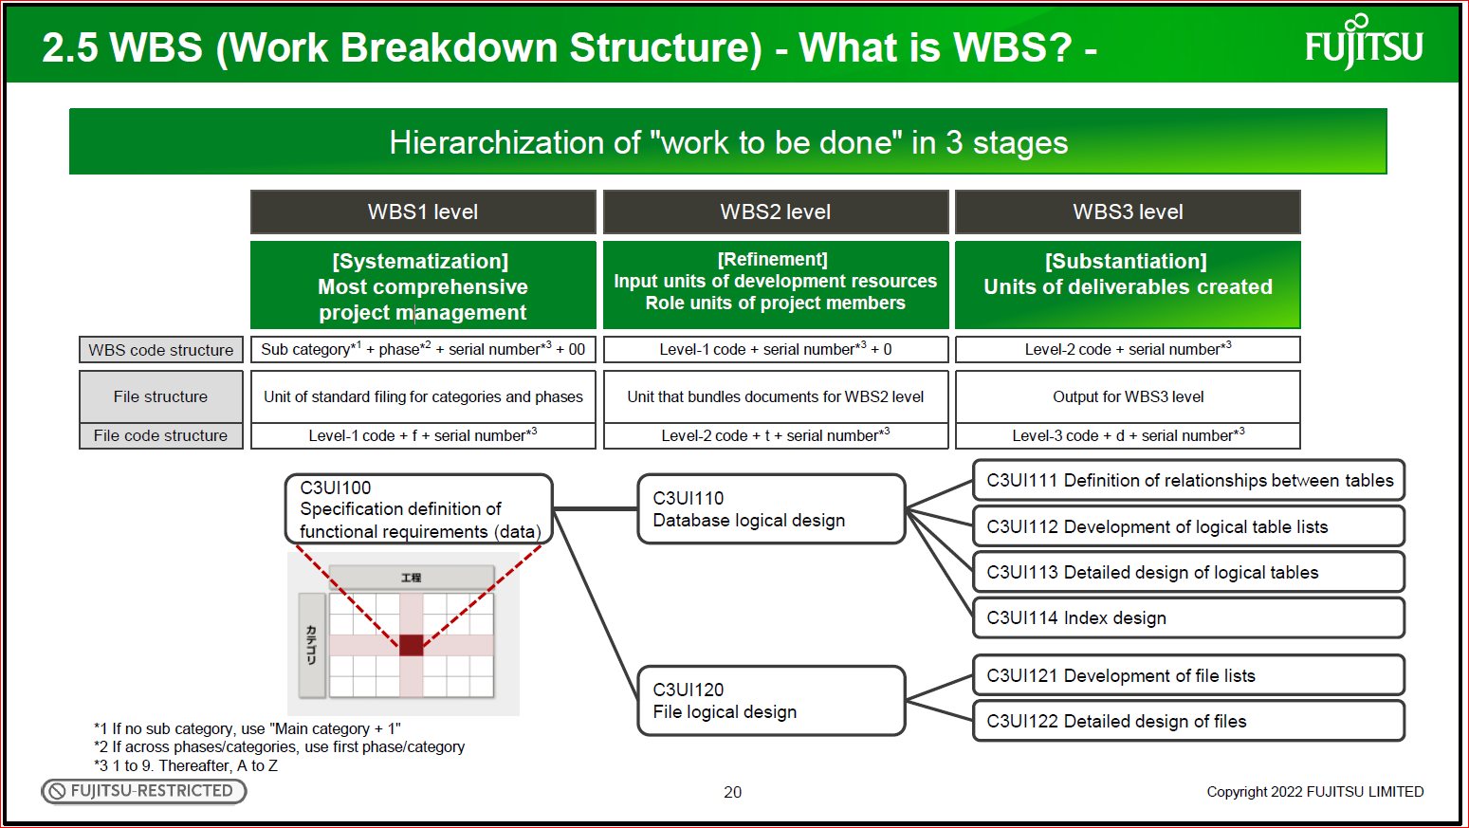
Hierarchization of "work to be done" in 3 stages

WBS1 level WBS2 level WBS3 level
[Systematization]
Most comprehensive
project management
[Refinement]
Input units of development resources

Role units of project members
[Substantiation]
Units of deliverables created
WBS code structure Sub category*1 + phase*2 + serial number*3 + 00 Level-1 code + serial number*3 + 0 Level-2 code + serial number*
3
*1 If no sub category, use "Main category + 1"
*2 If across phases/categories, use first phase/category
*3 1 to 9. Thereafter, A to Z
File structure Unit of standard filing for categories and phases
File code structure Level-1 code + f + serial number*3
Level-2 code + t + serial number*3
Level-3 code + d + serial number*3
Unit that bundles documents for WBS2 level Output for WBS3 level
C3UI100
Specification definition of
functional requirements (data)
C3UI110
Database logical design
C3UI120
File logical design
C3UI111 Definition of relationships between tables
C3UI112 Development of logical table lists
C3UI113 Detailed design of logical tables
C3UI114 Index design
C3UI121 Development of file lists
C3UI122 Detailed design of files

Here is an explanation of WBS.
"WBS" stands for Work Breakdown Structure, which is the structure of "work to be done" for each phase and
category.
SDEM hierarchizes it in three stages.
The WBS1 level is the systematization level, which provides an overall picture for comprehensive project management.
The WBS2 level is the refinement level, which refines the WBS1 work as the role units of project members.
The work here is also a unit for drawing up a detailed project schedule.
The WBS3 level is a more specific version of work at the WBS2 level.
Basically, the work here is a unit for creating deliverables.
The WBS of each layer is represented by assigned WBS codes indicating a category and phase.

20

2.5 WBS - Extended WBS Across Categories –
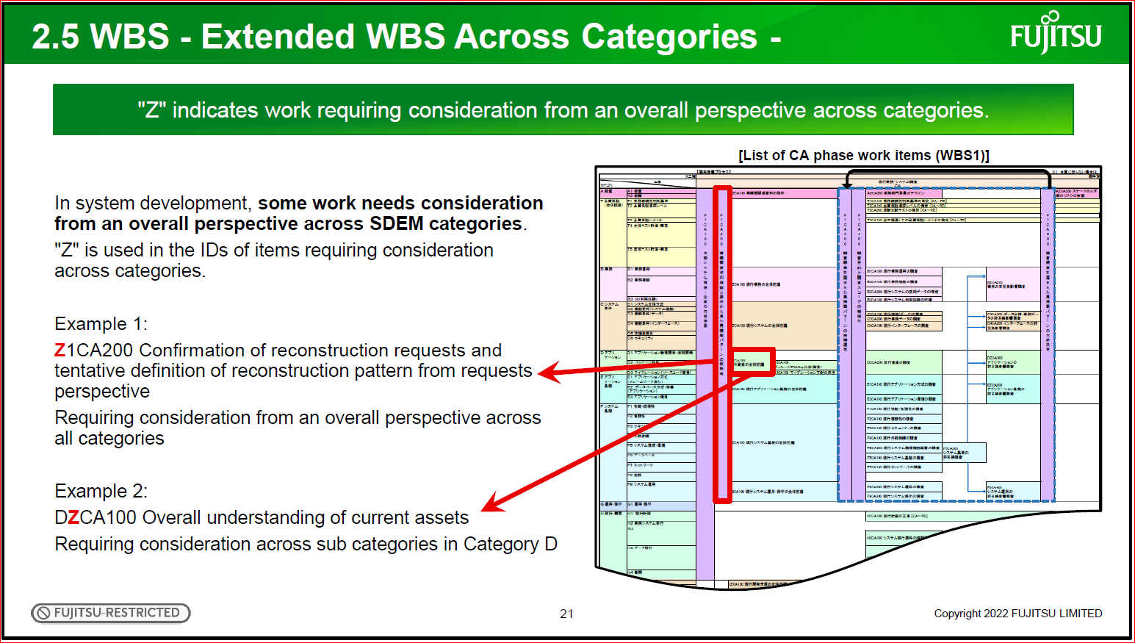
In system development, some work needs consideration from an overall perspective across SDEM categories.
"Z" is used in the IDs of items requiring consideration across categories.
Example 1:
Z1CA200 Confirmation of reconstruction requests and
tentative definition of reconstruction pattern from requests
perspective
Requiring consideration from an overall perspective across
all categories
Example 2:
DZCA100 Overall understanding of current assets
Requiring consideration across sub categories in Category D
Copyright 2022 FUJITSU LIMITED
"Z" indicates work requiring consideration from an overall perspective across categories.
[List of CA phase work items (WBS1)]

In system development, some work needs consideration from an overall perspective across SDEM categories.
For that work, the letter "Z" is used in the category part of the WBS code.

21

3. Each SDEM Process
What you will understand by the end of this chapter
- Definition and workflow of every phase in each SDEM process
- Role of each category of the SDEM requirement definition/development/operational test & transition process

Chapter 3 explains each SDEM process.
By the end of this chapter, you will understand the definition and workflow of each phase, and the role of
each category.

22

3.1 Planning Process

Section 3.1 is about the planning process.
This section explains the definition and workflow of each phase.

3.1 Planning Process - IT Vision Planning [VP] Phase –
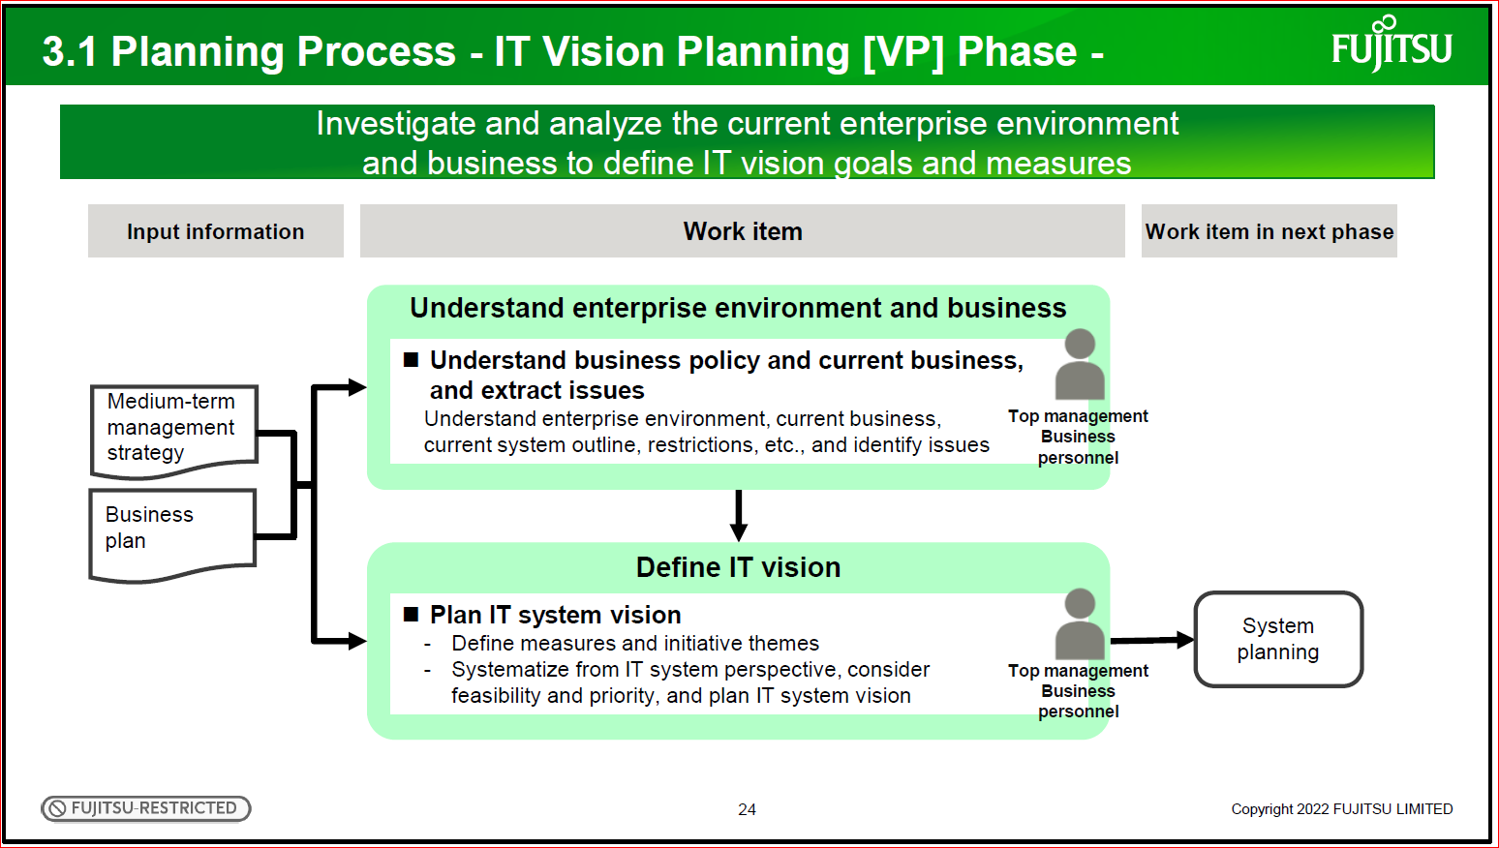
Investigate and analyze the current enterprise environment and business to define IT vision goals and measures.

Understand enterprise environment and business.
◼ Understand business policy and current business, and extract issues
Understand enterprise environment, current business, current system outline, restrictions, etc., and identify issues.
Define IT vision.
◼ Plan IT system vision
- Define measures and initiative themes
- Systematize from IT system perspective, consider feasibility and priority, and plan IT system vision

System
planning
Input information Work item Work item in next phase
Medium-term
management
strategy
Business
plan
Top management
Business
personnel
Top management
Business
personnel

The planning process includes the VP phase and SP phase. First, here is an explanation of the IT vision planning [VP] phase.
The purposes of the VP phase are to understand the current enterprise environment and business, and to
clearly define the IT vision.
The VP phase defines measures and initiative themes based on the management policy and business policy, taking current issues into account.
Then, the overall consistency, feasibility, and priority are considered from the IT system perspective and
summarized as the IT system vision.

24

3.1 Planning Process - System Planning [SP] Phase -
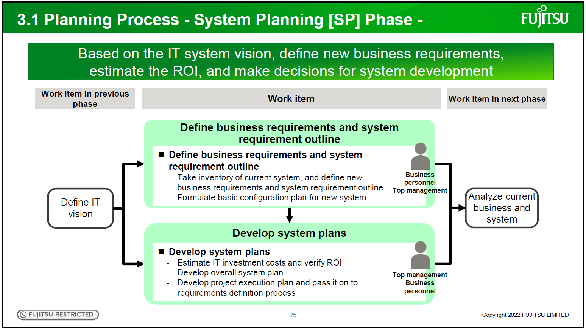
Based on the IT system vision, define new business requirements, estimate the ROI, and make decisions for system development
Define business requirements and system requirement outline
◼ Define business requirements and system requirement outline
- Take inventory of current system, and define new
business requirements and system requirement outline
- Formulate basic configuration plan for new system
Develop system plans.
◼ Develop system plans.
- Estimate IT investment costs and verify ROI
- Develop overall system plan
- Develop project execution plan and pass it on to
requirements definition process
Work item Work item in previous
phase Work item in next phase
Business
personnel
Top management
Top management
Business
personnel
Define IT
vision
Analyze current
business and
system

Here is an explanation of the system planning [SP] phase.
The purposes of the SP phase are to clarify what kind of system should be constructed and to define new
business requirements based on the IT system vision.
Agreement on the purpose and effects of the developed system is required of the parties concerned, in
consideration of the market and technology trends.
The SP phase defines new business requirements and system outline requirements, determines the overall
picture of the new system, and formulates a basic configuration plan for the new system.
The costs are estimated, including the system development and operational costs of the next phase, and the
ROI is verified based on the resulting estimates.
These are considered in the development of the overall system plan and project execution plan.

25

[Reference] Business & IT Grand Design Process Structure [BIeDP*]
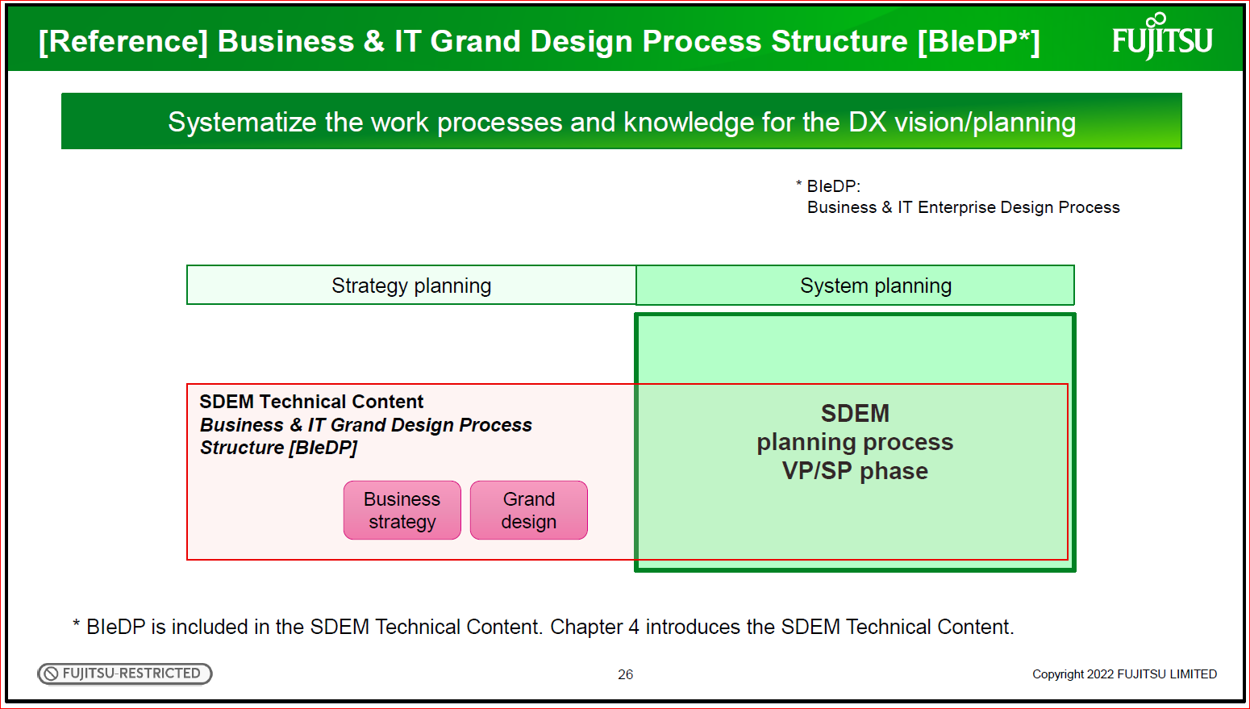
Systematize the work processes and knowledge for the DX vision/planning.

* BIeDP:
Business & IT Enterprise Design Process

Strategy planning System planning
SDEM Technical Content
Business & IT Grand Design Process
Structure [BIeDP]
Business
strategy
Grand
Design
SDEM
planning process
VP/SP phase

* BIeDP is included in the SDEM Technical Content. Chapter 4 introduces the SDEM Technical Content.

In business transformation utilizing the latest digital technologies, that is, DX, IT human resources familiar with digital technologies need to participate from the company-wide strategy planning and business strategy
planning stages, not from the planning process.
Customers should play the main role in developing the company-wide strategy and business strategy.
However, as a DX partner, we should understand the customers' ideas and provide support as an IT expert.
Business & IT Grand Design Process Structure [BIeDP] systematizes the work processes and knowledge for
the DX vision/planning.
Since it is provided in the SDEM Technical Content, use it to support the customers' DX vision/planning.
Chapter 4 introduces the SDEM Technical Content.

26
3.2 Requirement Definition/Development/Operational Test & Transition Process

Section 3.2 explains the requirement definition process, development process, and operational test &
transition process.
This section explains the roles of the categories, and then the definition and workflow of each phase.

27

3.2.1 Requirement Definition/Development/Operational Test &
Transition Process Categories (1)

Category
A: Business management
T: Quality assurance
(Overall test)
B: Business
C: System requirements
D: Application
E: Application
infrastructure
F: System infrastructure
G: Operation and
maintenance
H: Transition &
deployment
I: Development support
J: Project management
Main
Category
Description Sub Category
A: Business
management
Judge the ROI, determine project
startup, pause, transition, and
completion, as well as organize and
arrange organizations from the
viewpoint of business management.
A1: Business management
A2: Organization
T: Quality
assurance
(Overall test)
Promote overall test and manage
quality for the following purposes for
production:
- Risk measures at project startup
- Early risk measures during the
project
T1: Business operation
continuity judgment criteria
T2: Quality assurance
achievement level
T3: Quality assurance scenario
T4: Overall test plan and
execution
T5: Individual test plan
B: Business Establish business specifications and
perform business operational tests
from the viewpoint of users.
- Substantiate business requirements,
and determine business
specifications that the customer will
agree with.
- Design business operations, and
verify the operations as business.
B1: Business operation
B2: Business function
B3: UX (Usage experience)
Overall Control
Categories A and T correspond to "Overall control" and
Category B corresponds to "What customers want to achieve in business."
Infrastructure
Servers Storage Networks
System
infrastructure
OS
Middleware
Application
infrastructure
Applications
What
customers
want to achieve
(Business)
Cloud
Frameworks
Common parts
Operational
infrastructure Operations Architecture for connecting and moving everything.
Here is an explanation of the categories.
This page is about Categories A, T, and B. Categories A and T play the role of "Overall control" in system
development, and Category B corresponds to "What customers want to achieve in business."
Category A is "Business management," which is to judge the ROI, determine the project startup, pause,
transition, and completion, as well as organize and arrange organizations from the viewpoint of business
management.
The customer's top management is in charge of this category because it should be done from the viewpoint
of business management.
The sub categories subdivided from the main categories include "Business management" and
"Organization."
Category T is "Quality assurance (Overall test)," which is to promote the overall test and manage quality for
the following purposes for production: risk measures at project startup, and early risk measures during the
project.
It is important to work on this category with the customer and vendors as an entire project.
The sub categories are "Business operation continuity judgment criteria," "Quality assurance achievement
level," "Quality assurance scenario," "Overall test plan and execution," and "Individual test plan."
Category B is "Business," which is to establish business specifications and perform business operational
tests from the viewpoint of users. This category determine the specific business the customers want to
achieve.
The sub categories are "Business operation," "Business function," and "UX (Usage experience)."

28

3.2.1 Requirement Definition/Development/Operational Test &
Transition Process Categories (2)

Category C corresponds to "Architecture for connecting and moving everything" and
Categories D, E, and F correspond to the system structure from applications to infrastructures.
Main
Category
Description Sub Category
C: System
requirements
Design the overall system
architecture for doing business
and then pass on that
information to each category.
C1: Overall system architecture
C2: Functional requirements (System
functions)
C3: Functional requirements (Data)
C4: Functional requirements (Interface)
C5: Non-functional requirements
C6: Security
D: Application Design, develop, and test
applications (including
packages).
D1: New application development and
diversion development
D2: Package usage
D3: Migration (Source code conversion)
E: Application
infrastructure
Design and provide common
application functions deployed
as a common infrastructure.
E1: Application architectures (including
frameworks)
E2: Database architectures and
definitions (Applications)
E3: Application environment
F: System
infrastructure
Design and provide the system
configuration and environment,
network, databases, and system
operations that are required for
system implementation.
F1: Performance & scalability
F2: Reliability
F3: Security
F4: External connectivity
F5: System configuration & environment
F6: Database
F7: Network
F8: Facility
F9: System operation
Category
A: Business management
T: Quality assurance
(Overall test)
B: Business
C: System requirements
D: Application
E: Application
infrastructure
F: System infrastructure
G: Operation and
maintenance
H: Transition &
deployment
I: Development support
J: Project management
Infrastructure
Servers Storage Networks
System
infrastructure
OS
Middleware
Application
infrastructure
Applications
What
customers want
to achieve
(Business)
Cloud
Frameworks
Common parts
Operational
infrastructure Operations Architecture for connecting and moving everything

Here is an explanation of Categories C to F. Category C corresponds to the architecture for connecting and
moving everything, and Categories D, E, and F correspond to the system structure from application to
infrastructure.
Category C is "System requirements," which is to design the overall system architecture for doing business
and then pass on that information to each category.
The sub categories are "Overall system architecture," "Functional requirements (System functions),"
"Functional requirements (Data)," "Functional requirements (Interface)," "Non-functional requirements," and
"Security."
Category D is "Application," which is to design, develop, and test applications.
The sub categories are "New application development and diversion development," "Package usage," and
"Migration (Source code conversion)" depending on the application development method.
Category E is "Application infrastructure," which is to design and provide common application functions
deployed as a common infrastructure.
The sub categories are "Application architectures (including frameworks)," "Database architectures and
definitions (Applications)," and "Application environment."
Category F is "System infrastructure," which is to design and provide the system configuration and
environment, network, databases, and system operations that are required for system implementation.
Category F also includes the infrastructure, OS, middleware, and operational infrastructure.
The sub categories are classified by elements for meeting non-functional requirements. They include
"Performance & scalability," "Reliability," "Security," "External connectivity," "System configuration &
environment," "Database," "Network," "Facility," and "System operation."

29

3.2.1 Requirement Definition/Development/Operational Test &
Transition Process Categories (3)
Category G corresponds to "Post-production preparation" and
Categories H, I, and J correspond to "Work required in system construction/operation."

Main Category Description Sub Category
G: Operation and
maintenance
Prepare for operation and
maintenance after production
(transition, etc.).
G1: Operation & maintenance
H: Transition &
deployment
Plan and design transition and
deployment, and perform transition
rehearsal and the actual transition.
H1: Transition plan
H2: Business system transition
H3: Data transition
H4: Deployment
I: Development
support
Establish development standards for
overall project integration, and
develop and operate a framework for
configuration management, tools,
etc.
I1: Development standard
I2: Configuration management
J: Project
management
Develop project plans and establish
project goals (deadline, quality, cost,
etc.) for production, and promote and
operate the project.
J1: Integration management
J2: Scope management (Requirement
management)
J3: Time management (Progress management)
J4: Cost management (Profit and loss
management)
J5: Quality management (Quality and defects
management)
J6: Human resource management (Personnel
management)
J7: Communications management (Information
distribution and performance report)
J8: Risk management (Risk control)
J9: Procurement management (External
procurement management)
JA: Contract management (Contracts with
customers)
JB: OSS application management
Category
A: Business management
T: Quality assurance
(Overall test)
B: Business
C: System requirements
D: Application
E: Application
infrastructure
F: System infrastructure
G: Operation and
maintenance
H: Transition &
deployment
I: Development support
J: Project management
Infrastructure
Servers Storage Networks
System
infrastructure
OS
Middleware
Application
infrastructure
Applications
What
customers
want to achieve
(Business)
Cloud
Frameworks
Common parts
Operational
infrastructure Operations Architecture for connecting and moving everything
Work required in system
construction/operation
Post-production
preparation

Last is Categories G to J.
Category G corresponds to "Post-production preparation." Categories H, I, and J correspond to "Work required in system construction/operation."
Category G is "Operation and maintenance," which is to prepare for operation and maintenance after
production. The only sub category is "Operation & maintenance."
Category H is "Transition & deployment," which is to plan and design transition and deployment, and
perform transition rehearsal and the actual transition.
The sub categories are "Transition plan," "Business system transition," "Data transition," and "Deployment."
Category I is "Development support," which is to provide support for smooth development practice, establish development standards for overall project integration, and develop and operate a framework for
configuration management, tools, etc.
The sub categories are "Development standard" and "Configuration management."
Category J is "Project management," which is to develop project plans and establish goals such as deadline,
quality, and cost for production, and promote and operate the project.
There are eleven sub categories in total. "Integration management," "Scope management (Requirement
management)," "Time management (Progress management)," "Cost management (Profit and loss
management)," "Quality management (Quality and defects management)," "Human resource management
(Personnel management)," "Communications management (Information distribution and performance
report)," "Risk management (Risk control)," and "Procurement management (External procurement
management)" correspond to the knowledge area in the PMBOK 6th Edition. "Contract management
(Contracts with customers)" and "OSS application management" are unique to SDEM.

30

3.2.2 Requirement Definition Process - Current Business and System Analysis [CA] Phase –
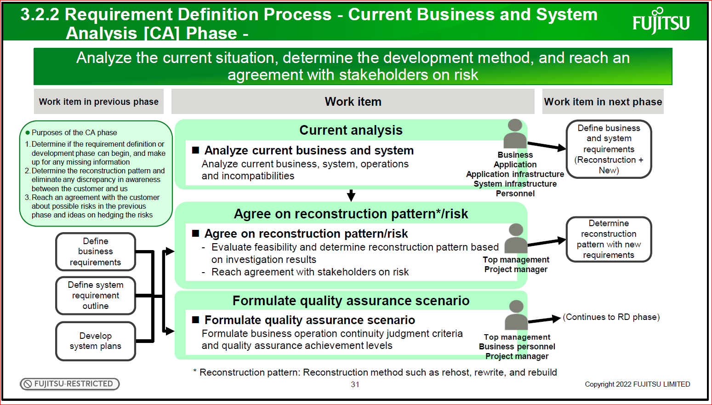
Analyze the current situation, determine the development method, and reach an agreement with stakeholders on risk.
Current analysis
Formulate quality assurance scenario
◼ Formulate quality assurance scenario
Formulate business operation continuity judgment criteria and quality assurance achievement levels
◼ Analyze current business and system
Analyze current business, system, operations and incompatibilities
Develop
system plans
Define business and system requirements (Reconstruction + New)
Top management
Business personnel
Project manager
Work item in previous phase Work item Work item in next phase
Define system requirement outline
Define business requirements
(Continues to RD phase)
Agree on reconstruction pattern*/risk
◼ Agree on reconstruction pattern/risk
- Evaluate feasibility and determine reconstruction pattern based on investigation results
- Reach agreement with stakeholders on risk
Business
Application
Application infrastructure
System infrastructure
Personnel
Top management
Project manager
Determine
reconstruction
pattern with new
requirements
⚫ Purposes of the CA phase
1.Determine if the requirement definition or
development phase can begin, and make
up for any missing information
2.Determine the reconstruction pattern and
eliminate any discrepancy in awareness
between the customer and us
3.Reach an agreement with the customer
about possible risks in the previous
phase and ideas on hedging the risks
* Reconstruction pattern: Reconstruction method such as rehost, rewrite, and rebuild
Each phase will be explained. First, the requirement definition process phase.
The requirement definition process includes the CA and RD phases. This page explains the current
business and system analysis [CA] phase.
The CA phase has three purposes.
The first is to determine if the requirement definition or development phase can begin, and make up for any
missing information.
The second is to determine the reconstruction pattern and eliminate any discrepancy in awareness between
the customer and us.
The third is to reach an agreement with the customer on possible risks in the previous phase and ideas on
hedging the risks.
In order to realize these purposes, analyze the current business, system, operations, and incompatibilities,
and evaluate the feasibility and determine the reconstruction pattern based on the investigation results.
Next, reach an agreement with the customer on risk.
In addition, for quality assurance after production, formulate the business operation continuity judgment
criteria and the quality assurance achievement levels.
Note that the reconstruction pattern means the reconstruction method such as rehost, rewrite, and rebuild.

31

3.2.2 Requirement Definition Process - System Requirement Definition [RD] Phase –
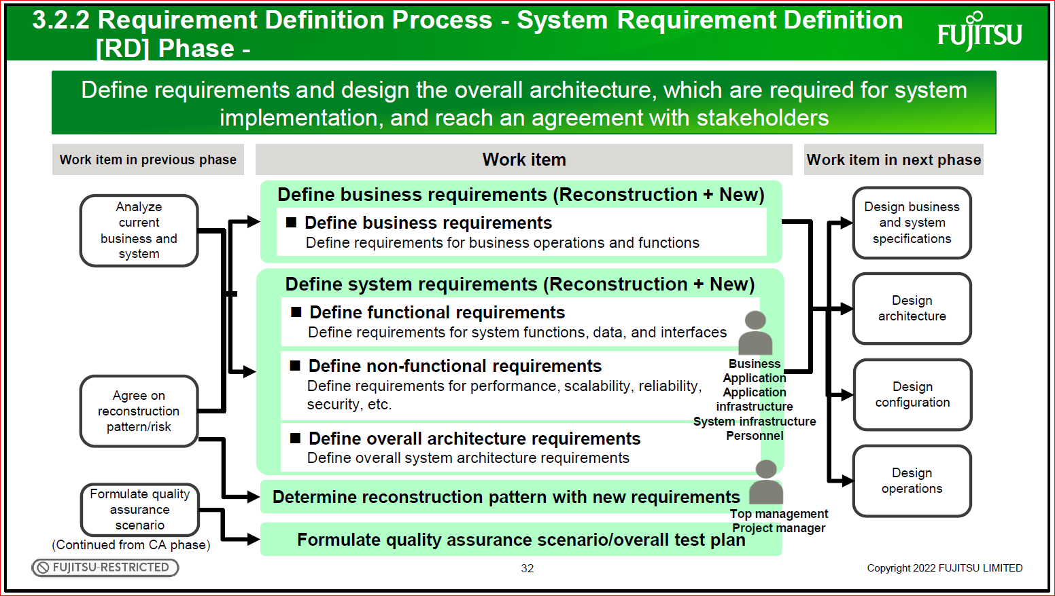

Define requirements and design the overall architecture, which are required for system implementation, and reach an agreement with stakeholders
Define system requirements (Reconstruction + New)
◼ Define functional requirements
Define requirements for system functions, data, and interfaces
◼ Define non-functional requirements
Define requirements for performance, scalability, reliability,
security, etc.
Analyze
current
business and
system
Design
configuration
Design
architecture
Design business
and system
specifications
Design
operations
Work item in previous phase Work item Work item in next phase
◼ Define overall architecture requirements
Define overall system architecture requirements
Business
Application
Application
infrastructure
System infrastructure
Personnel
Determine reconstruction pattern with new requirements
Agree on
reconstruction
pattern/risk
Formulate quality assurance scenario/overall test plan
Formulate quality
assurance
scenario
(Continued from CA phase)
Top management
Project manager
Define business requirements (Reconstruction + New)
◼ Define business requirements
Define requirements for business operations and functions

Here is an explanation of the system requirement definition [RD] phase.
The purposes of the RD phase are to define requirements and design the overall architecture, which are
required for system implementation, and reach an agreement with stakeholders.
Define the requirements for business operations and functions, integrating reconstruction requirements and
new requirements. System requirement definition is divided into functional requirements and non-functional
requirements. The functional requirements include those for system functions, data, and interfaces. The
non-functional requirements include those for performance and scalability, reliability, and security. In
addition, define the requirements for the overall system architecture.
Finally, confirm the reconstruction pattern determined in the CA phase, formulate the quality assurance
scenario and overall test plan, and reach an agreement with stakeholders on requirement definition.

32

3.2.3 Development Process - User Interface Design [UI] Phase –
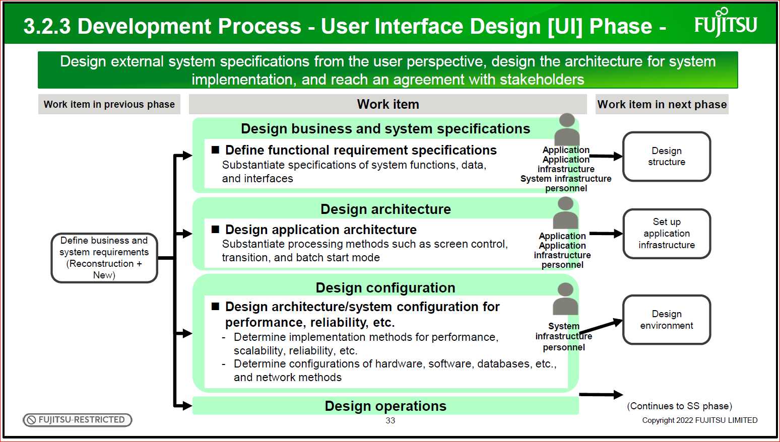
Design external system specifications from the user perspective, design the architecture for system
implementation, and reach an agreement with stakeholders
Design architecture
Design business and system specifications
◼ Define functional requirement specifications
Substantiate specifications of system functions, data,
and interfaces
◼ Design application architecture
Substantiate processing methods such as screen control,
transition, and batch start mode
Define business and
system requirements
(Reconstruction +
New)
Set up
application
infrastructure
Design
structure
Application
Application
infrastructure
System infrastructure
personnel
Application
Application
infrastructure
personnel
(Continues to SS phase)
Work item in previous phase Work item Work item in next phase
Design operations
Design configuration
◼ Design architecture/system configuration for
performance, reliability, etc.
- Determine implementation methods for performance,
scalability, reliability, etc.
- Determine configurations of hardware, software, databases, etc.,
and network methods
Design
System environment
infrastructure
personnel

The explanations from here cover the phases of the development process. The development process
includes the phases from UI to ST.
First is an explanation of the user interface design [UI] phase.
The purposes of the UI phase are to design external system specifications from the user perspective, design
the architecture for system implementation, and reach an agreement with stakeholders.
In designing business and system specifications, substantiate the system functions, data, interfaces,
screens, and forms based on the requirement definition of the RD phase.
In addition, design the application architecture, design an architecture for ensuring performance, reliability,
etc., and determine the configurations of hardware, software, databases, etc.
Furthermore, as operation design, design the operation methods, etc. for stable, abnormal, or maintenance
operations.

33

Here is an explanation of the system structure design [SS] phase.
The purpose of the SS phase is to design for system implementation.
In so doing, develop the design agreed upon with the stakeholders.
The design for implementation in this phase is based on the business and system specifications,
architecture design, configuration design, and operation design in the UI phase.
In designing the application structure, define the program divisions and functions.
In setting up the application infrastructure, create application infrastructure programs one stage earlier than
the start of business programming.
Then, in designing the environment, develop the environment design such as parameters related to
hardware and software installed in the system, develop the physical design of the databases, and so on.

3.2.3 Development Process - System Structure Design [SS] Phase -
Set up application infrastructure
Design structure
◼ Design application structure
- Divide process into programs in functional units
- Define program function outline
◼ Develop application infrastructure programs
Develop application infrastructure programs (Programming,
program test)
Application
infrastructure
personnel
Design
configuration
Design
architecture
Set up
environment
Implement
Design business
and system
specifications Application
personnel
Work item in previous phase Work item Work item in next phase
Design for system implementation, and confirm that the user interface design
reflects the specifications agreed upon
Design environment
◼ Design system environment, database, etc.
- Design system environment such as hardware and software
- Develop physical and environmental designs of databases,
and design network environment
System
infrastructure
personnel
Design operations
Design
operations
(Continued from the UI phase)
34
This and the next page explain the program structure design [PS] phase, programming [PG] phase, and
program test [PT] phase collectively as the implementation phase.
First is an explanation of application-related work.
The PS phase develops program structure designs, such as module division, and the detailed designs of
logic and algorithms to definitely incorporate the design results of the SS phase into programs.
The PG phase performs program coding.
The PT phase verifies the programs implemented in program units and ensures quality.
Copyright 2022 FUJITSU LIMITED 35
3.2.3 Development Process - Implementation Phase [PS to PT] (1) -
Copyright 2022 FUJITSU LIMITED
Create programs and ensure quality by verifying them in program units
Implement
◼Design
program
structure
Develop structural
designs, such as
module division,
and detailed
designs
◼Do
programming
Perform coding,
etc.
◼Test programs
Run tests on
programs
PS phase PG phase PT phase
◼Develop integration test specifications
Develop integration test specifications
Design
structure
Set up
application
infrastructure
Run
integration test
Application
personnel
Work item in previous phase Work item Work item in next phase
35
3.2.3 Development Process - Implementation Phase [PS to PT] (2) -
Copyright 2022 FUJITSU LIMITED
Set up and verify the system infrastructure environment
Test system
infrastructure
Set up environment
◼Install hardware and software,
and check operations
- Install hardware and software, and
configure their environment
- Develop system infrastructure test
specifications
◼Test system
infrastructure
[Up to IT]
Run tests on
system
infrastructure
◼Install database, etc.
- Install and configure database
environment, network devices, etc.
- Develop system infrastructure test
specifications
System
infrastructure
personnel
Design
environment
(Continues to test phase)
Design
operations
Work item in previous phase Work item Work item in next phase
PS phase PG phase PT phase
System
infrastructure
personnel
36
Here is an explanation of the system infrastructure work.
Set up the environment during the PS phase to PG phase.
Install hardware and software, set parameters, and install and configure the database environment, network
devices, etc.
In the PT phase, test the environment that has been set up. Run the system infrastructure test by the first
half of the IT phase.
Copyright 2022 FUJITSU LIMITED 36
This page explains the integration test [IT] phase and system test [ST] phase collectively as the test phase.
The purposes of the IT phase are to integrate programs whose quality was confirmed in the PT phase, and
to verify the quality of integrated functions and interfaces between functions.
First, run the integration test for the business applications overall.
Next, after the system infrastructure test is completed, run the integration test for the business applications
on the system infrastructure. Also, verify interface quality by integrating the business and infrastructure.
The purposes of the ST phase are to verify the overall system quality and to confirm the achievement of the
quality assurance achievement levels formulated together with the customer.
In the system test, verify the overall system from functional aspects, non-functional aspects such as
performance and reliability, and operational aspects. For the test, use the data and system environment
appropriate to the actual business operations if possible.
Copyright 2022 FUJITSU LIMITED 37
3.2.3 Development Process - Test Phase [IT to ST] -
Copyright 2022 FUJITSU LIMITED
Verify the quality of integrated functions and interfaces between functions [IT]
Verify the overall system quality, and confirm the achievement of the quality assurance
achievement levels [ST]
System infrastructure
test
Integration test
◼Integration test
Test functions of
business
applications overall
◼System
infrastructure test
[PT and later]
Test system
infrastructure
System test
◼System test
Run test
appropriate to
business operations
Verify overall
system
- Functionality
- Non-functionality
(Performance,
scalability,
reliability, etc.)
- Operation
Implement
(Continued from
implementation
phase)
Run
operational
test
Application
personnel
System
infrastructure
personnel
Work item Work item in
previous phase
Work item in next
phase
Integration test
(Business and
infrastructure
integration)
◼Integration test
Integrate business
applications and
infrastructure, and
test interfaces
IT phase ST phase
Application
Application
infrastructure
System
infrastructure
personnel
Application
Application
infrastructure
System
infrastructure
personnel
37
This page explains the operational test & transition process phase. The phase is operational test and
transition [OT].
The purposes of the OT phase are to make a business operation continuity judgment based on business
scenario verification results, etc., make production decisions based on that, and transition to the new
system.
As the operational test, users verify the business scenario. Based on the business operation continuity
judgment criteria and production agreed upon with the customer, determine if production is possible and if
transition to the new system is possible.
When there is no problem, perform transition and deployment of the system and data.
Copyright 2022 FUJITSU LIMITED 38
3.2.4 Operational Test & Transition Process - Operational Test and
Transition [OT] Phase -
Copyright 2022 FUJITSU LIMITED
Make production decisions based on a business scenario verification and
business operation continuity judgment to transition to the new system
Transition and
deployment
Transition decision
making
Operational test
◼ Operational test
and transition to
new business
- Users become familiar
with system and
understand problems
in business operations
- Switch from current
business to new
business
◼ Transition
decision
making
Evaluate whether
quality goal was
achieved, and
make decision on
transition
◼ Transition
Perform
transition of
system and data
User
◼ Deployment
Deploy
Top
management
System test
Transition and
deployment
personnel
Production
Work item in previous phase Work item
38
The explanations so far have covered the roles of categories of the SDEM requirement definition,
development, operational test & transition processes, and the definition and workflow of each of their
phases.
This diagram shows the main workflow in requirement definition, development, operational test & transition.
The explanations so far have mainly covered construction work and quality assurance. In addition to that,
preparation for operation and maintenance after production, work for transition and deployment,
development support, project management, and various other work have been defined.
Copyright 2022 FUJITSU LIMITED 39
Copyright 2022 FUJITSU LIMITED
Process/Phase
Category
Planning Requirement Definition Development
Operational
Test &
Transition
Operation &
Maintenance
VP SP CA RD UI SS PS PG PT IT ST OT OM
A: Business management
T: Quality assurance
(Overall test)
B: Business
C: System requirements
D: Application
E: Application
infrastructure
F: System infrastructure
G: Operation and
maintenance
H: Transition &
deployment
I: Development support
J: Project management
Define
enterprise
requirements
Define
business
requirements
(Outline)
Make
development
decisions
Define
business
requirements
Define
system
requirements
Design
system
specifications
Design
structure Implement Integration
test
System test Operational
test
Make
transition
decision
Design
configuration
and operations
Set up
application
infrastructure
Design
environment
Design architecture
Set up environment
Set up environment
System infrastructure
test
Prepare for transition and
deployment
Rehearse
and preverify
Transition
and deploy
Substantiate development standards and manage configuration
Execute, monitor, and control the project, and manage changes Develop the project
plan
Design
architecture
Analyze current business and system
Agree on reconstruction pattern/risk
Formulate quality assurance
scenario
Prepare for operation and
maintenance
Develop test plan
Integrate
business and
infrastructure
Develop transition
plan
Design
business
specifications
Understand
overall operation
and
maintenance
Understand Train users and operation/maintenance personnel
operational and
maintenance
requirements
Perform
operation
and
maintenance
3.2.5 Main WBS Flow of Requirement Definition/Development/Operational Test &
Transition Process
39
Section 3.3 explains the operation & maintenance process.
Copyright 2022 FUJITSU LIMITED 40
3.3 Operation & Maintenance Process
40 Copyright 2022 FUJITSU LIMITED
The operation & maintenance process includes only the operation and maintenance [OM] phase because it
has no concept of start and end like in a development project.
In the OM phase, develop a plan for safe and stable operation of the system, and regularly review and
improve the plan cyclically.
For daily operation and maintenance, go through a cycle centered on operation management, from business
operation, system operation, application maintenance, and infrastructure maintenance request to delivery.
Engage in integrated management from the perspective of management and business.
Copyright 2022 FUJITSU LIMITED 41
3.3 Operation & Maintenance Process - Operation and Maintenance
[OM] Phase -
Copyright 2022 FUJITSU LIMITED
C1: Integrated management (Operation and maintenance management, business continuity planning, etc.)
D1: Business operation
(Business monitoring, business
troubleshooting, business operation
document management, etc.)
D3: Application maintenance
(Application failure support, application
modification/specification change, data
maintenance, etc.)
D2: System operation
(System monitoring, system
troubleshooting, system operation
document management, etc.)
D4: Infrastructure
maintenance
(Hardware failure support, software
failure support, network failure support,
database environment change, etc.)
C2: Operational management
(Service desk, incident management,
problem management, operational
improvement, etc.)
Users (Manager/End users)
Software/Hardware vendors
Regular report
Support request
Support contract
Delivery
A: Business management (Business management, organization)
B: Business (Business operation)
Support contract
Delivery
Change request
collaboration
Change request
collaboration
Joint study
Release discussion
E1: Infrastructure provision (Facility provision/management, IT resource provision, etc.)
G: Project management (Scope management, time management, cost management, etc.)
Develop a plan for safe and stable operation of the IT system, and regularly
review and improve the plan
* A: Business management,
B: Business,
C1: Integrated
management, etc. are
categories.
41
Chapter 4 explains the SDEM content structure.
By the end of this chapter, you will understand the content provided with SDEM, types of SDEM practical
standards, which are part of it, and what is provided.
Copyright 2022 FUJITSU LIMITED 42
4. SDEM 2.0 Content Structure
Copyright 2022 FUJITSU LIMITED
What you will understand by the end of this chapter
- What kind of content is provided with SDEM
- Types of SDEM practical standards, and what is provided
42
SDEM broadly consists of the SDEM Standard Processes, the SDEM Practical Standards, and the SDEM
Technical Content.
The SDEM Standard Processes are a general-purpose work structure independent of industry, language,
development environment, and so on. It covers the overall work required for planning, development,
operation and maintenance, and quality assurance activities.
They contain three types of content: Standard Process Structure, WBS Manual, and Standard Process
Guide.
The SDEM Practical Standards are provided as more practical work standards for each field.
Document formats, samples, specific work procedures, and guides are provided.
The SDEM Technical Content contains technical know-how and document samples useful in practicing
Fujitsu project work.
Starting with the next page, the content provided in the SDEM Standard Processes is introduced.
Copyright 2022 FUJITSU LIMITED 43
4.1 Overall SDEM Structure
43 Copyright 2022 FUJITSU LIMITED
First is an explanation of the Standard Process Structure.
This content includes the WBS1 and WBS2 structures, categories, and phase definitions of the SDEM
standard processes.
Take advantage of the content to get an overall picture of the SDEM standard processes.
When estimating project work and planning role division, be sure to use this standard process structure.
In addition, WBS1, WBS2, and WBS3 lists are provided in CSV format. Use them for project standardization,
WBS name extraction in schedule creation, etc.
Copyright 2022 FUJITSU LIMITED 44
4.2 SDEM Standard Processes - Standard Process Structure -
● SDEM (WBS1-2 structure) key point summary
Copyright 2022 FUJITSU LIMITED
[Planning, requirement definition, development, operational test &
transition, operation & maintenance process WBS1]
[Explanation of categories and phases]
⚫ WBS1-2 provided
⚫ Printable (A3) files also provided
⚫ WBS data in CSV format also provided
(WBS1-2-3)
Use for project planning (estimation, schedule creation, role
division), etc.
Use to:
- Collect detailed tasks
- Extract the WBS name in schedule creation
44
Next is about the WBS Manual in the SDEM Standard Processes.
This content is provided in WBS2 units.
It shows what to input or output in each WBS, and the key points of work and viewpoints for consideration
for WBS3 individually.
Use it to understand work you are experiencing for the first time, and so on.
This content also includes the WBS purpose.
When performing work, it is important to understand the purpose of the work.
When reading the WBS Manual, pay attention to this purpose to deepen your understanding.
Copyright 2022 FUJITSU LIMITED 45
4.2 SDEM Standard Processes - WBS Manual -
● Explanation of key points of work in each WBS
Copyright 2022 FUJITSU LIMITED
* The WBS Manual is not provided for Categories C
to E in the operation & maintenance process
(OM).
See the SDEM Practical Standards: Operation and
Maintenance (ITSMOP).
⚫ Provided in WBS2 units
⚫ Describes the WBS purpose and input/output
⚫ Describes key points of work and viewpoints for
consideration for WBS3 individually
Use to:
- Understand the procedure and viewpoints of
work you are in charge of
- Get reviewers and auditors to check if they
missed some checks
45
The third type of content in the SDEM Standard Processes is the Standard Process Guide.
This page shows the table of contents of the guide.
This content explains each SDEM process and the concepts of SDEM application methods.
The Standard Process Guide has been divided into an internal version and the FUJITSU-CONFIDENTIAL
version. The internal version explains the key points to progressing smoothly in a project.
Read it if you want to understand these points or want to understand SDEM in more detail than provided in
this training course.
These pages have explained the Standard Process Structure, WBS Manual, and Standard Process Guide in
the SDEM Standard Processes.
Next is an explanation of the SDEM Practical Standards.
Copyright 2022 FUJITSU LIMITED 46
4.2 SDEM Standard Processes - Standard Process Guide -
Copyright 2022 FUJITSU LIMITED
Purpose of SDEM® 2.0 Renewal
Chapter 1 What is SDEM?
1.1 Need for Standardization
1.2 Fujitsu Standardization
1.3 Incorporation of Global/De Facto Standards
1.4 History of Standardization at Fujitsu
Chapter 2 SDEM Structure
2.1 Processes
2.2 Categories
2.3 Phases
Chapter 3 Planning Process
3.1 Overall Flow
3.2 Categories
3.3 Phases
Chapter 4 Requirement Definition/Development/
Operational Test & Transition Process
4.1 Overall Flow
4.2 Categories
4.3 Phases
Chapter 5 Operation & Maintenance
Process
5.1 Overall Flow
5.2 Categories
5.3 Phases
Chapter 6 Contract/Organizational Management/System Audit Process
6.1 Contract Process
6.2 Organizational Management Process
6.3 System Audit Process
Chapter 7 Applying SDEM
Chapter 8 System Development Concepts Where "It is Natural for Existing Systems
to Exist"
8.1 Concept of New Development
8.2 Concept of Reconstruction
Conclusion
Appendix 1. File Structure
Appendix 2. Main Workflow of Requirement Definition Process (CA to RD Phases)
Appendix 3. Reconstruction Pattern
Appendix 4. Relationship Between Global/De Facto Standards and SDEM
Appendix 5. Details of SDEM 2.0 Changes
For internal
use
For internal
use * Parts of Chapter 4 and Appendix 5 are confidential information.
Therefore, the confidential information has been from the Standard Process Guide (FUJITSU-CONFIDENTIAL version) used by customers and partners.
● Explains SDEM concepts and application methods * Table of contents is below
Use if you:
- want to understand SDEM in more detail than
provided in this training course
- are a project manager who wants to understand
key points within the company to proceed
smoothly with projects
46
The SDEM Practical Standards provide more practical procedures and guides, document formats and
samples, etc., such as Business Application Development and System Infrastructure for each process and
category.
Use it to understand practical know-how about work you are in charge of or to determine the document
standards for a project.
Copyright 2022 FUJITSU LIMITED 47
4.3 Structure of SDEM Practical Standards
Copyright 2022 FUJITSU LIMITED
The SDEM Practical Standards provides specific work procedures, document formats,
etc. in practice.
* For the location of document formats and samples, including the SDEM Practical Standards, see "ドキュメントフォーマット・サンプル格納場所" (Document format/sample
storage location) on the following page:
https://fujitsu.sharepoint.com/sites/jp-IKB-sdem/SitePages/technology/sdeminformation.aspx
Use to:
- Understand practical know-how about work you
are in charge of
- Determine the document standards for a project
47
Chapter 5 explains how to apply SDEM to projects.
By the end of this chapter, you will understand the concept of applying SDEM to projects, the concept and
important points of tailoring, and the concept of utilizing SDEM in agile development.
Copyright 2022 FUJITSU LIMITED 48
5. Applying SDEM
Copyright 2022 FUJITSU LIMITED
What you will understand by the end of this chapter
- Concept of applying SDEM to projects
- Concept and important points of tailoring
- Concept of utilizing SDEM in agile development
48
The first is the concept of applying SDEM to projects.
SDEM is a comprehensive structure of work to be done in system construction. SDEM is not premised on a
specific product, system form, or implementation means.
Therefore, to apply it to an actual project, tailoring according to the project characteristics is necessary.
"Tailoring" means to customize the depth of WBS implementation according to project characteristics.
The viewpoints of tailoring include system characteristics, such as the scale and application type, and
conditions such as the development model, new development or reconstruction, skill level, and development
form.
Copyright 2022 FUJITSU LIMITED 49
5.1 Applying SDEM to Projects
Copyright 2022 FUJITSU LIMITED
SDEM is a comprehensive structure of work to be done in system construction. SDEM is not premised on a specific application
(scale or system form) or implementation means (process model, technique, tool).
Therefore, to apply it to an actual project, tailor (customize the depth of) and utilize the WBS implementation according to
the project characteristics.
Tailor and utilize according to project characteristics.
Project Characteristics
System
Characteristics
Technical
Conditions
Development
Conditions
- Scale
- Application type
- Core
system/Information
system
- Quality
requirements
etc.
- Development model
(Waterfall, agile,
etc.)
- New development,
reconstruction,
service application
- Methods/Tools
etc.
- Development
period
- Skills/Scheme
- Development
form
etc.
SDEM
Project standards
Tailoring
according to
project
characteristics
[Viewpoint of tailoring]
49
Here is an explanation of the concept of tailoring.
In many cases, you will refer to similar projects in the past to determine the project standards. The benefits
this will bring include a greater awareness of additional work due to project characteristics or optimization of
the formulation of the project standards. On the other hand, there is a risk that the work required for this
project will be omitted. Therefore, while referring to past projects, start tailoring based on all WBS of SDEM.
Especially for WBS1 and 2 level work, consider implementing every WBS once.
When deciding against implementation, it is important to be able to explain to a third party why the project
requirements can be met without the implementation. An example of a reason is that they are clearly not
applicable depending on the project scope.
A careless decision will lead to quality problems.
Depending on the development framework and applied language, for example, you may need to make a
choice or review the work at the WBS3 level.
There are special points to keep in mind when integrating or dividing a phase.
For example, depending on the project, the PS and PG phases are integrated in many cases.
However, as an example, do not integrate the RD phase of the requirement definition process and the UI
phase of the development process, or the ST phase of the development process and the OT phase of the
operational test & transition process.
The purposes of the phases differ greatly, so it is essential to judge the completion of each phase.
Conversely, it may be better to divide a phase.
For example, by dividing the IT phase into IT1, IT2, and IT3 depending on the scope of integration, you can
clarify the purpose to be achieved in each of them, and manage the quality, progress, etc. in divisions.
Copyright 2022 FUJITSU LIMITED 50
5.2 Concept of Tailoring
● WBS tailoring
Tailoring is implemented based on the following concepts.
⚫ Integrate and divide phases
Point 1. Do not integrate phases of different processes
As an example, do not integrate the RD phase of the requirement definition process and the UI phase of the development
process, or the ST phase of the development process and the OT phase of the operational test & transition process. The
purposes of the phases are different. Make sure the phases are independent of each other regardless of the period length.
Point 2. Divide a phase
If a phase has many system components (business, sub system, etc.) due to the project characteristics, divide the phase.
When dividing a phase and defining the sub phases, make it clear that the purpose of the original phase can be achieved, and
clarify the purpose and outline of each sub phase along with its name.
[Example of dividing the IT phase]
IT1 (Inter-program integration test within process), IT2 (Inter-process integration test), IT3 (Interface test with external system)
Copyright 2022 FUJITSU LIMITED
WBS1 Basically covers the implementation of all WBS
WBS2 Basically covers the implementation of all WBS
WBS3 Selects the WBS to be implemented according to project characteristics
Determines the depth of work to be done
50
51
This chapter ends with an explanation of how to use SDEM in agile development.
Agile development has no concept of dividing a phase. However, the fact remains that requirement
definition, design, implementation, and testing are agile actions.
The work and examination viewpoints defined in the SDEM WBS are the elements required for system
development.
Ascertain and utilize the required elements flexibly according to the purpose of development in the project.
Copyright 2022 FUJITSU LIMITED
5.3 Concept of Utilizing SDEM in Agile Development
The work and examination viewpoints defined in the SDEM WBS are the elements
required for system development.
Ascertain and utilize the required elements according to the purpose of development.
Copyright 2022 FUJITSU LIMITED
Planning/Research
Development Continuous development
Project first end  Respond to new issues Verify
...
Hypothesize
Design
Request
Test
Implement
Release
Verify
...
Verify
...
Operation/Maintenance Operation/Maintenance
Agile development has no concept of dividing a phase. The actions in each short
development cycle are requirement definition, design, implementation, and testing.
Check requests and repeat implementation in the short cycle to continuously create value.
Agile development
51
Chapter 6 explains specific SDEM usage scenarios.
By the end of this chapter, you will understand when to use SDEM, what can be done with SDEM, how far
the SDEM provision scope extends, and where to obtain SDEM.
Copyright 2022 FUJITSU LIMITED 52
6. SDEM Usage Scenarios
Copyright 2022 FUJITSU LIMITED
What you will understand by the end of this chapter
- When to use SDEM
- What can be done with SDEM
- How far the SDEM provision scope extends
- Where to obtain SDEM, and contact information
52
6.1 Use SDEM at These Times
● Project manager
Copyright 2022 FUJITSU LIMITED
Estimate costs
Plan scheme/role
division
Create master
schedule
⚫Extract the required work, and assume the work volume from the work description
⚫Plan a scheme by assuming the required skills from the categories corresponding to the
work, and divide the work
⚫Extract the work to be performed or approved by the customer, and the perceptions of both
parties are aligned beforehand
● Team leader (Business team, system infrastructure team, etc.)
Create detailed
schedule ⚫Extract all tasks in the team to create a schedule
● Team member
Implement initial
work ⚫Understand the procedure and viewpoints of the work
● Quality auditor in the organization
Create checklist ⚫Check if some checks were missed in the audit
What can be done with SDEM
Standard Process
Structure WBS Manual
Content used in relevant scenarios
WBS1-2-3 data
53
Here is an explanation of the typical usage scenarios of SDEM for each role.
The icons on the right represent the content mainly used in the scenario.
A project manager can use SDEM to estimate costs, create a master schedule, and plan a scheme and role
division.
All required work, including that related to the customer, can be extracted. This can be used not only for
planning Fujitsu's work but also for planning work where you need to share a common perception with the
customer early.
The next page explains an image of planning a scheme and role division using SDEM categories.
The leader of a business team, infrastructure team, or subsystem team can extract all the work in the team
by referring to specific WBS work to create a detailed schedule.
Team members will understand the procedure and viewpoints of the work even when experiencing the work
for the first time. They will also understand the positioning of their work in the overall work.
SDEM can be used not only in a project but also by quality auditors in the organization.
The auditors can check if they missed some checks on a checklist used in the audit.
Copyright 2022 FUJITSU LIMITED 53
Here is an explanation of an image of specific usage.
The figure on this page is an image showing SDEM usage for planning a project scheme and role division.
The SDEM categories are classified based on the relevance of knowledge and skills required for work. The
categories are used to clarify the targets such as application, infrastructure, and operations, and to define
the scheme and roles of the project.
As shown in the figure, confirm that all elements in the category, including the customer's scheme, are
assigned in order to prevent omissions and gaps in role division.
Copyright 2022 FUJITSU LIMITED 54
6.2 SDEM Usage Scenario 1) Planning Project Plan Scheme and Role
Division
Copyright 2022 FUJITSU LIMITED
[Example of development scheme planning]
A: Business management
T: Quality assurance
(Overall test)
B: Business
C: System requirements
D: Application
E: Application infrastructure
F: System infrastructure
G: Operation and maintenance
H: Transition & deployment
I: Development support
J: Project management
<Development process>
Project owner
Project manager
<Customer>
Business team
System infrastructure
team
Operation and
maintenance team
Transition and
deployment team
Project manager
Business team A Business team B
Application team A Application team B
Application
infrastructure team
<Fujitsu>
System infrastructure team
Operation and
maintenance team
Transition and
deployment team
Development
support team
Project owner
Use SDEM categories to clarify the targets (application, infrastructure, etc.)
and define roles for each group in the project.
Confirm that all elements in the category are assigned in order to prevent omissions
and gaps in role division.
54
55
Here is an explanation of another image of specific usage. This page explains a usage scenario for creating
a schedule.
First, extract the work and output required for the project from the SDEM WBS to create a schedule.
Then, you can assign and schedule all the deliverables you need to create.
Copyright 2022 FUJITSU LIMITED SDEM
A
B
C
D
E
.
J
VP SP CA . . OT OM
SDEMstandard
WBS
Collect required
work items
Collected Work Items
C4UI111 Screen transition design
C4UI112 Screen layout design
C4UI113 Screen item design
C4UI141 Collection of common
business messages
Work Item Document Person
-hours Personnel Schedule
Screen transition
design
Screen transition
diagram
10 A
Screen layout
design
Screen layout 7 B
Screen item
design
Screen item
definition
15 B
Collection of
common business
messages
Business
message list
30 C
I can create schedules
effectively without
omitting work items!
[New system project] Person-hour estimates/role division/schedule
Assign
deliverables and
personnel
New system
project leader
6.3 SDEM Usage Scenario 2) Creating Schedule
Define the project WBS based on the SDEM WBS, and create work items/schedules.
55 Copyright 2022 FUJITSU LIMITED
Here is an explanation of the scope of provision of SDEM 2.0.
SDEM is Fujitsu's core technology and important know-how for Fujitsu to outsource SI.
Therefore, provision to a customer or business partner is based on the premise that Fujitsu is entrusted with
SI.
In addition, a non-disclosure agreement, representing a confidentiality agreement, must be concluded.
As shown in the table, some content cannot be provided outside the company.
Furthermore, the scope of provision of the SDEM Practical Standards is determined by content.
When using it, check "利用上の注意事項" (Precautions for Use) on the IKB site.
Copyright 2022 FUJITSU LIMITED 56
6.4 Scope of SDEM 2.0 Provision
Copyright 2022 FUJITSU LIMITED
SDEM is copyrighted by Fujitsu, and the scope of provision varies depending on the content.
SDEM is Fujitsu's core technology and important know-how for Fujitsu to outsource SI.
Therefore, provision to an external party is based on the premise that an NDA is concluded and
Fujitsu is entrusted with SI.
SDEM Structure
Internal Provision
Scope External Provision Scope
Within
Company/Group
Business
Partner Customer
SDEM
Standard
Processes
Standard Process Structure ✓ ◆ ◆
WBS Manual ✓ ◆ ◆
Standard Process Guide
(FUJITSU-CONFIDENTIAL) ✓ ◆ ◆
Standard Process Guide
(for internal use)
✓ x x
WBS1-2-3 work item list
(CSV format)
✓ x x
[Legend]
✓: Can be provided
◆: Can be provided after the
conclusion of a non-disclosure
agreement (NDA), representing a
confidentiality agreement, on the
premise that Fujitsu is entrusted
with SI
x: Cannot be provided or shown
* For the provision scope of the SDEM Practical Standards, see "利用上の注意事項" (Precautions for Use) on the following page:
https://fujitsu.sharepoint.com/sites/jp-IKB-sdem/SitePages/technology/attention.aspx
56
⚫ A variety of information such as introductory materials and the content introduced in this training
course is available on the IKB-SDEM site.
6.5 SDEM 2.0 Published by IKB-SDEM
Copyright 2022 FUJITSU LIMITED
(IKB-SDEM site) https://fujitsu.sharepoint.com/sites/jp-IKB-sdem/SitePages/sdem.aspx
⚫ For inquiries, please contact us from [Inquiry] on the menu on the IKB-SDEM site.
* English versions of the
following content are
also available:
- SDEM Standard
Processes: Standard
Process Structure
- SDEM Practical Standards:
Operation and
Maintenance [ITSMOP]
57
The SDEM content introduced in this training course and the textbooks for this training can be obtained from
the IKB-SDEM site. Please make use of them.
For inquiries, please contact us from [Inquiry] on the menu.
The standard process structure "SDEM" is available to provide a system that our customers can use with
peace of mind. SDEM is the culmination of Fujitsu SE's wisdom and covers all system development tasks,
including the customer ones.
Please use SDEM to work with good quality and without omission.
Copyright 2022 FUJITSU LIMITED 57
Thank you
Copyright 2022 FUJITSU LIMITED
Copyright 2022 FUJITSU LIMITED 58

